LAB EXPERIMENT RECORD
Set 8: Employee Performance Analysis
Department | AIML
Course Code / Course Name | DSA0601 / Data Handling and Visualization
Experiment | Data Visualization using R and Tableau
Name | G. GANGA CHANDRIKA
Register Number | 1925260144
Date | 3 October 2026
Day | Saturday
Aim
To visualize employee performance data using a line chart, a bar chart and a data table in R, and to build an interactive dashboard combining them in Tableau.
Dataset: Employee Performance
Employee ID | Department | Years of Service | Performance Score
1 | Sales | 5 | 85
2 | HR | 3 | 92
3 | Marketing | 7 | 78
PROGRAM 1: Line Chart of Employee Performance Trend
Create a line chart to visualize the performance trend of employees over time. Label the axes and title the chart.
# Dataset
employee <- data.frame(
Employee_ID = c(1, 2, 3),
Department = c("Sales", "HR", "Marketing"),
Years_of_Service = c(5, 3, 7),
Performance_Score = c(85, 92, 78)
)

# Line Chart
plot(employee$Years_of_Service,
employee$Performance_Score,
type = "o",
xlab = "Years of Service",
ylab = "Performance Score",
main = "Employee Performance Trend",
pch = 16)

text(employee$Years_of_Service,
employee$Performance_Score,
labels = employee$Employee_ID,
pos = 3)
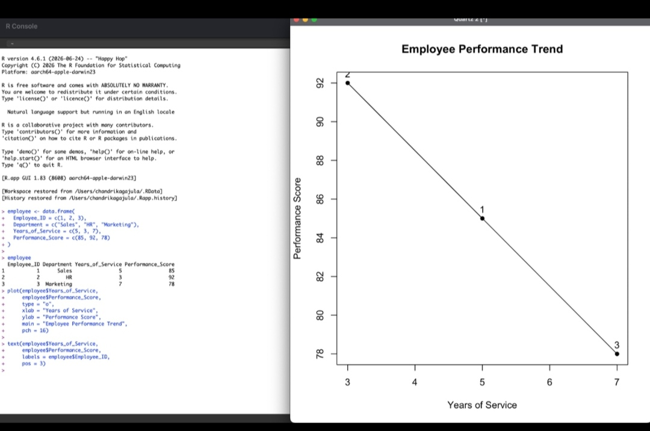
Output 1: Employee Performance Trend Line Chart
Observation: The performance score falls as years of service increase. Employee 2 (3 years) has the highest score of 92, Employee 1 (5 years) scores 85, and Employee 3 (7 years) has the lowest score of 78.
PROGRAM 2: Bar Chart of Employees by Department
Generate a bar chart showing the distribution of employees across different departments. Label the chart elements.
# Count employees in each department
department_count <- table(employee$Department)

# Bar Chart
barplot(department_count,
main = "Distribution of Employees by Department",
xlab = "Department",
ylab = "Number of Employees",
col = "skyblue")
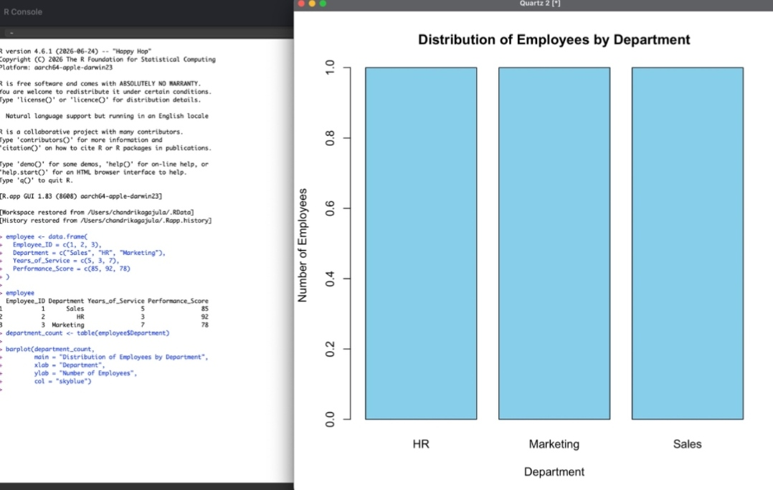
Output 2: Distribution of Employees by Department
Observation: Each of the three departments (HR, Marketing and Sales) has exactly one employee, so all bars have the same height of 1.
PROGRAM 3: Table of Employee Performance Data
Build a table to display the performance data for each employee. Label the table elements.
library(knitr)

kable(employee,
caption = "Employee Performance Data",
col.names = c("Employee ID",
"Department",
"Years of Service",
"Performance Score"))
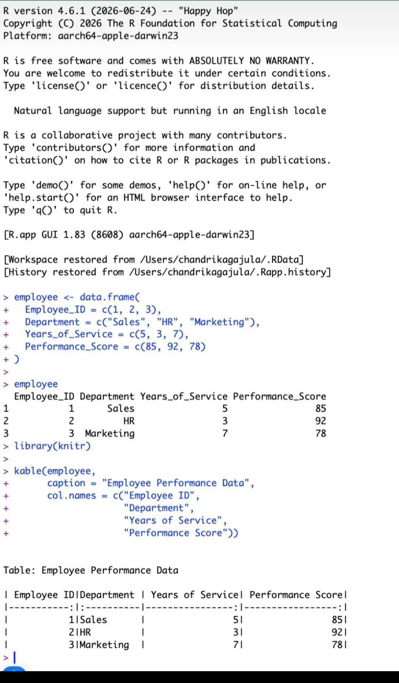
Output 3: Employee Performance Data Table
Observation: The table lists the Employee ID, Department, Years of Service and Performance Score of each employee with labelled column headings and a caption.
PROGRAM 4: Tableau Dashboard
Develop a Tableau dashboard combining the line chart, bar chart and table for interactive exploration of employee performance data.
Procedure:
1. Open Tableau and connect to the employee performance data (Employee_ID, Department, Years_of_Service, Performance_Score).
2. Create the first sheet, Employees by Department: place Department on Columns and Count of Employee_ID on Rows to get the bar chart.
3. Create the second sheet, Employee Performance Table: place the four fields on the sheet to show each employee's data as a text table.
4. Create the third sheet, Performance Trend: place Years of Service on Columns and Performance Score on Rows and use the line mark type.
5. Create a new dashboard and drag the three sheets onto it. Title the dashboard and enable the Use as Filter option so that the charts respond to each other.
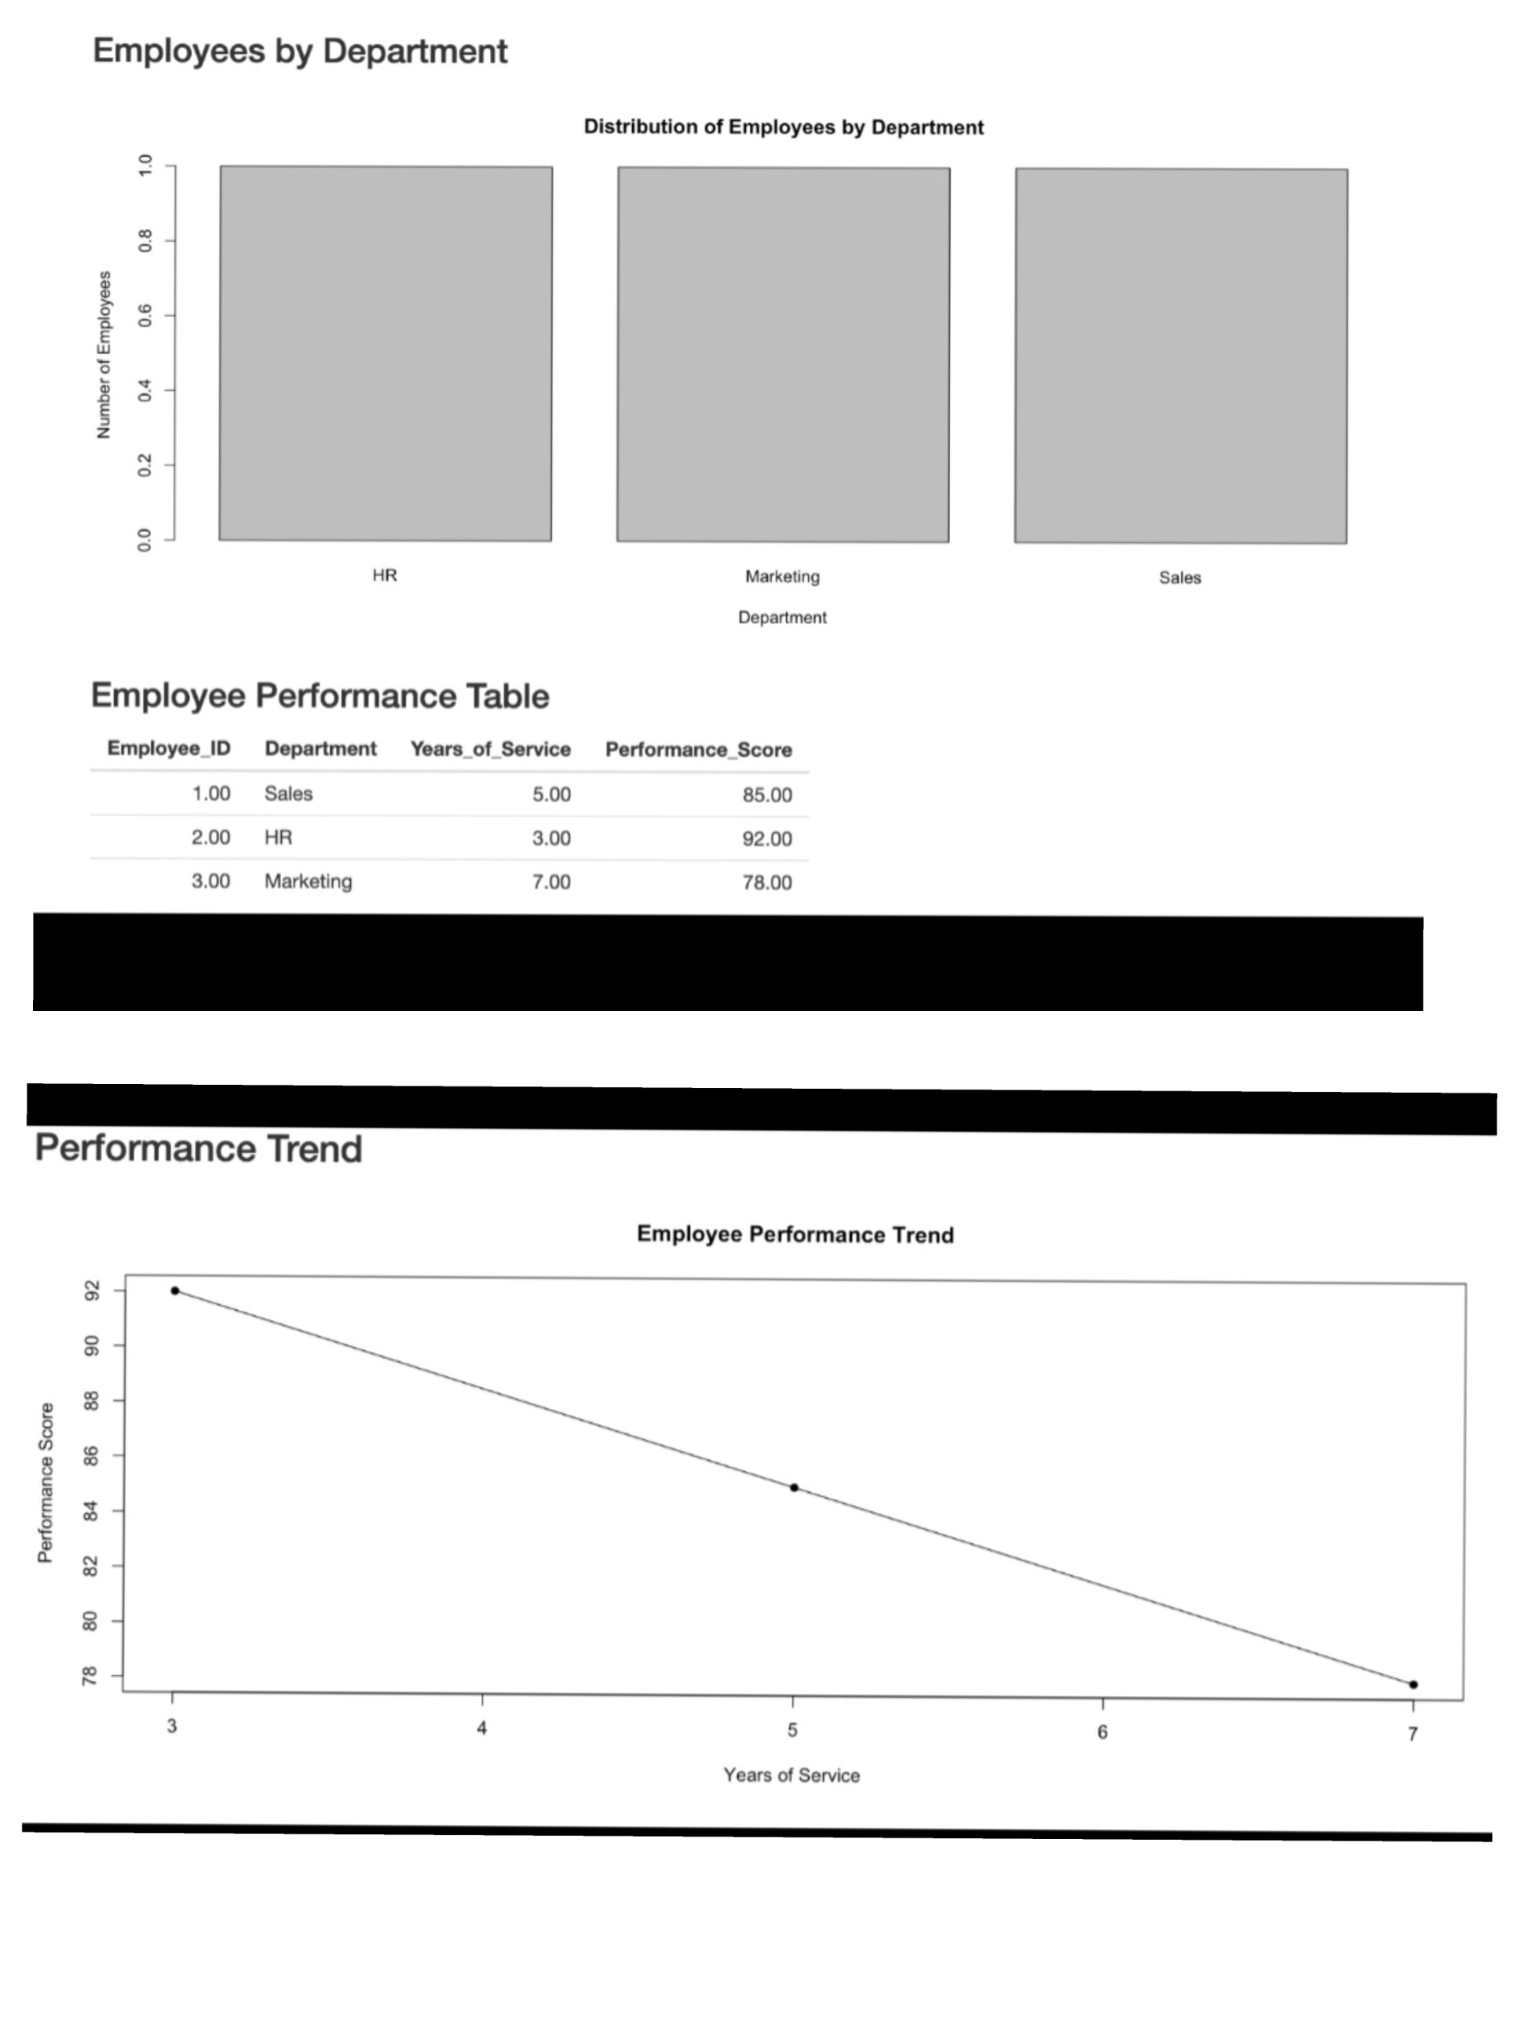
Output 4: Employee Performance Dashboard (Tableau)
Observation: The dashboard shows the department bar chart, the employee performance table and the performance trend line chart on a single page, allowing the data to be explored interactively.
Result
The employee performance data was successfully visualized in R using a line chart, a bar chart and a table, and an interactive dashboard combining all three was created in Tableau.

